Component 1 Themes – Issues of Human Rights
Key words
Censorship – Suppressing and limiting access to materials considered obscene, offensive or a threat to security. Restricting speech.
Discrimination – Acts of treating groups of people, or individuals differently, based on prejudice.
Extremism – Believing in and supporting ideas that are very far from what most people consider correct or reasonable.
Human rights –Basic entitlements of all humans, given simply because they are human. E.g. All should receive an education.
Personal conviction – Something a person strongly feels or believes in.
Prejudice – Pre-judging; judging people to be inferior or superior without reason.
Relative poverty – A standard of poverty measured in relation to the standards of a society in which they live. E.g below average UK wage.
Absolute poverty – An acute state of deprivation, whereby a person cannot access the most basic of their human needs.
Social justice – Promoting a fair society by challenging injustice and ensuring diversity. Everyone has equal access to provisions and rights.
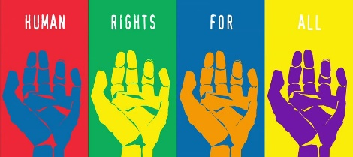
Oppressed – Governed or treated with cruelty or injustice.
Ummah – The worldwide community of Muslims.
Zakah – A pillar of Islam; compulsory payment of 2.5% of savings to help others.
Anti-Semitic – Hostile towards or prejudiced against Jews.
Islamophobic – Hostile or prejudiced against Muslims.
Evangelise – To try and convert someone to a different religion (often used as a term in Christianity)
Marginalised – Put in a place of little importance.
Apartheid – A system of segregating people by races which was used in South Africa.
Human rights | Social justice |  |  |  | Censorship
Universal moral rights for all people no matter who they are. 1948 United Nations Declaration of Human Rights contains a list of all human rights starting with ‘all are born free and equal in dignity and rights. Most countries agreed to this list and are held to account when they break them. Amnesty International is a charity that monitors injustice around the world through protests, writing to governments, using the media and education. Sometimes a religious belief can conflict with a human right such as same-sex marriages.  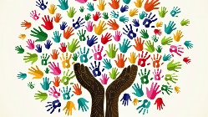 | Governments and agencies often work together to help developing countries by closing the gap between the rich and poor divide and looking after the environment by tackling pollution. Dignity of human life is at the centre of social justice. Christians argue the UN Declaration of Human Rights reflect their beliefs. We were made in the image of G-d so life is to be treated with respect. This might mean Catholics would be against euthanasia or the death penalty. The sanctity of life means everyone should be treated with agape love (unconditional). It is the example of Jesus so many charities reflect this in their work, like the Salvation Army who help the homeless. Liberation theology argues that Jesus was an example who someone who liberated people from unjust economic, political and social conditions. Some Christians stand up against their governments through peaceful protest and have been persecuted and even killed. The priest Oscar Romero is one example in El Salvador. He spoke out against corruption of rich people after his friend was murdered. The government killed him during his church service.  Muslims oppose injustice as the Qur’an teaches equality for all. Even criminals should not be mistreated when punished. The Ummah is a community that looks after each other irrespective of race or wealth. They give zakah and do Sadaqah to help those who suffer. Islamic Relieif is a charity that responds to needs around the world. |  |  | Article 19 of the UN Declaration of Human Rights says, ‘everyone has a right to freedom of opinion and expression.’ The problems are some say:  No public views should be allowed that offend. Religious views should stay in private.  We should be allowed to say anything.  Should the Charlie Hebdo drawings of the Prophet Muhammad be censored?  Should people be allowed to be anti-Semitic, homophobic, Islamophobic on Twitter?  How far should there be freedom of religious expression?
Freedom of religious expression |  | Religious extremism | Prejudice and discrimination
Religion is expressed in many ways. Sometimes clothing or symbols are not allowed. In France, a secular country, no obviously religious symbolism can be work in schools. A British Airways worker had denied her right to wear her crucifix until the court said she could. For Christians and Muslims, religious expression is an important way to evangelise to people and convert them. They believe it is their duty. Without freedom of religious express as a basic human right, these religions are denied their duty.  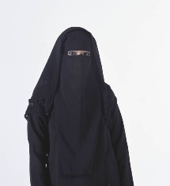  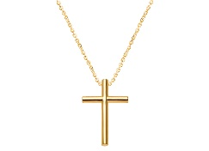 |  | There is a fine line between freedom of speech and the actions that accompany them when extreme. Some extreme Christians who oppose abortion have become violent in their protests. For some, their faith is so important they interpret it in a very narrow way which can lead to extreme beliefs and actions. They believe they are doing the work of G-d. Examples might be the Westboro Baptist Church in America who hate homosexuals, the KKK who promote white superiority and Daesh, the Islamist terror group who hate the West.  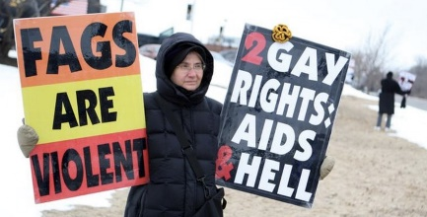 | Prejudice is what you think, discrimination is acting upon this thought. Governments have sometimes discriminated stopping people do certain jobs, marrying someone, going to a place of worship, living somewhere and voting. Britain has laws to protect people but there are still some issues:  - Not all buildings allow access for disabled people still  - Some companies have a ‘glass ceiling’ which stops some people from being promoted.  - Religious beliefs stop women from becoming Catholic priests.  Religious discrimination is often borne out of ignorance. One example is Islamophobia. It can include:  - Name-calling  - Attacks on places of worship  - Burning scriptures / acts of violence  - Not allowed to wear symbols

Religious attitudes to prejudice and discrimination |  |  | Racism
Christians believe in the sanctity of life therefore all are equal. The prophet Moses gave guidance for how to live. He wrote that strangers/foreigners must be accepted. Jesus’ life modelled treating all people with respect. He helped the marginalised by healing the lepers and women. He became friends with a tax collector even though Jews would never normally associate with them. St. Paul said there should be no discrimination between race, gender, religion or status. However, the Catholic Church do not let women become priests as there is no biblical evidence. St. Paul argued that women should be silent in church and not have authority over a man. However, the Church of England allow women priests and more recently bishops.  Muslims believe all are equal but different. They condemn all forms of discrimination as the Ummah breaks through all gender, race and wealth barriers. On the hajj pilgrimage to Mecca, Muslims all wear white to show equality. This also happens when buried. The Qur’an teaches equality and Prophet Muhammad’s final sermon preached unity. However, the roles of men and women are different. The Qur’an doesn’t say women cannot be imams, however it has traditionally been a male role. Some Muslim scholars allow women to lead salat (prayer) as in the Hadith, Prophet Muhammad’s wives Aisha and Umm Salamah led prayer. In some Sunni mosque if the congregation is all women then women can led prayer. |  |  | In Britain racism is against the law. There are campaigns to stop it happening, especially at football matches. ‘Show Racism the Red Card’ is an anti-racism charity that combats racisms using sports celebrities to preach an anti-racist message to young people working in schools to educate.  Christians promote equality of all races and use the Parable of the Good Samaritan to show Jesus’ teaching on the matter. If the Samaritan would help the Jew from a race he didn’t culturally get along with, how much more should we do the same? The Church of England promotes racial equality through a committee which encourages ethnic minorities to become priests and has inter-faith dialogue to promote community cohesion. Martin Luther King Jr is a case study of a Baptist Minister campaigning against racial segregation in 1950s America. Using non-violent protests he delivered the famous ‘I have a dream’ speech which changed history.  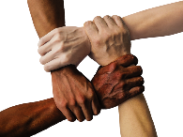  Muslims believe Prophet Adam was created from different coloured soil showing diversity. The Prophet Muhammad’s good friend Bilal was the first muezzin to call Muslims to prayer and he was a former black slave.
Wealth | Poverty
Wealth is not evenly spread out in society. There is a rich and poor divide.  - Some jobs receive high salaries like footballers whilst others receive much lower pay.  - Some business owners make a lot of profit as it grows.  - Some inherit money from a dead relative.  - Some get money through crime like fraud or burglary.  - Some get rich through risky gambling and the stock market.  Britain is considered to be a materialistic society yet at the same time it is one of the most giving to charities.  Many debate whether money can truly bring happiness. | Absolute poverty – a set standard which is consistent over time and between countries. It usually includes having no access to basic services like medicine or shelter.  Relative poverty – A level of income below the majority of one particular country.  Poverty in the UK is typically relative as most people have accommodation and the State provides support for people who need it through council houses and benefits. However:  - 2 million are malnourished without enough food (Oxfam)  - Food poverty is rising with the need for food banks by government to help  - 3.7 million child are living in poverty (Barnardos)  - Children born into poor families are likely to develop illness and not do well in education which continues the cycle.  Christians believe you should be judged by actions and not wealth and status. Money is not evil but the love of it is. Jobs are not banned for creating wealth, but it shouldn’t exploit the poor. Whilst gambling is not specified as a sin in the Bible, many Christian frown upon it as it is not being a good steward of your money. Quakers are completely opposed to gambling as it promotes greed. Jesus taught money doesn’t make you happy. Some Christians are aesthetics and vow to give up wealth and live in poverty. The Parable of the Sheep and Goats teaches that G-d will not judge you on the amount of wealth you have but whether you have helped the poor. Christians are encouraged to give a tithe (10%) of their income to the Church or charity.  Muslims believe wealth is a gift from Allah are we are caretakers with a duty to help the poor. Zakah (2.5% of income) is donating to charity. The Qur’an forbids certain jobs such as money lenders as receiving or making interest is forbidden. There are Islamic banks set up to accommodate this. Gambling is a sin. Shi’a Muslims give an additional 20% of khums to help the Ummah. Sadaqah is a voluntary act of kindness to help those in need. During Ramadan donations are given to the poor as Muslim fast (sawm) and think about those who are less fortunate than them.
Christian Aid |  | Islamic Relief
A charity in 60 countries to help the poor regardless of their religious belief. It believes in the dignity of all human life and seeks to bring justice and equality to all.  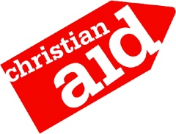 |  | Founded in 1994 in Britain, it works in 40 countries. Responds to disasters and emergencies and helps with shelter, healthcare and education. They do not just help Muslims although they promote the welfare of the Ummah. They are compassionate because Allah is all merciful. They sponsor over 30,000 orphans and recycle used clothes in the UK to sell and use the money to help the poor.  