**The Bourne Academy**

**Knowledge Organiser: Year 9 Autumn Term - Dance**

**1. Safe Practice**

Safe practice refers to personal care, respect for others, safe execution and preparation and recovery from dancing.​

**a) Personal Care**

* Dance kit (appropriate, not too tight and not too loose)​
* Jewellery removed​
* Hair tied back​
* No socks

**b) Respect for others**

* Spatial Awareness - Consciousness of the surrounding space and its effective use.​
* Respect others in the room​

**c) Safe Execution**

* No hazards
* Correct temperature

**d) Preparation and Recovery**

* Warm up- pulse raiser, mobilization, strengthening and dynamic stretches​
* Cool down- lowers heart rate to resting rate, static stretches

**3. Cool Down**

Cool downs are essential in order to restore cardiorespiratory, muscular and metabolic function, reduce joint aches and muscle soreness, reduce injuries and mental stress.

A cool down usually consist of 3-5 minutes of easy exercise, light jog or walk. Followed by 5 minutes of low intensity, static stretching held for 30 to 60 seconds with deep diaphragmatic breathing. Re-hydrating and re-fuelling are also essential parts to a cool down, drinking water and easily digestible foods like fruit.

**2. Warm Up**

A thorough warm-up prepares the body and mind to safely meet the challenges of a class, rehearsal, or performance. A warm-up increases core body temperature, which prepares the muscles and joints for the demands of dancing. A warm-up should be carried out before all dance activities and, if effective, can improve physical and psychological performance while reducing the risk of injury.

A warm-up generally consists of three or four sections: a gentle pulse-raising section, a joint mobilizing section, a muscle lengthening section, and sometimes a second pulseraising section. The pulse-raising sections aim to increase cardiorespiratory and metabolic rates; these are essential to all further activity. The joint mobilizing section consists of gently moving the various joints through their ranges of motion, and the purpose of the muscle lengthening section is to prepare the muscles for the demands to come through the use of dynamic stretching.

**4. Choreographic Devices**

Choreographic devices are ways movement is manipulated to create choreography.

|  |  |
| --- | --- |
| **Choreographic Device** | **Definition** |
| **Motif and development** | Using a single movement or short movement phrase that is manipulated (eg, by varying the elements of movement, by repetition, by fragmentation, using different body parts) to develop movement sequences for a dance.​ |
| **Repetition** | Performing the same action or phrase again. |
| **Contrast** | Movements or shapes that have nothing in common. |
| **Highlights** | Important moments of a dance. |
| **Climax** | The most significant moment of the dance. |
| **Manipulation of Number** | How the number of dancers in a group is used. |

**The Bourne Academy**

**Knowledge Organiser: Year 9 Autumn Term - Dance**

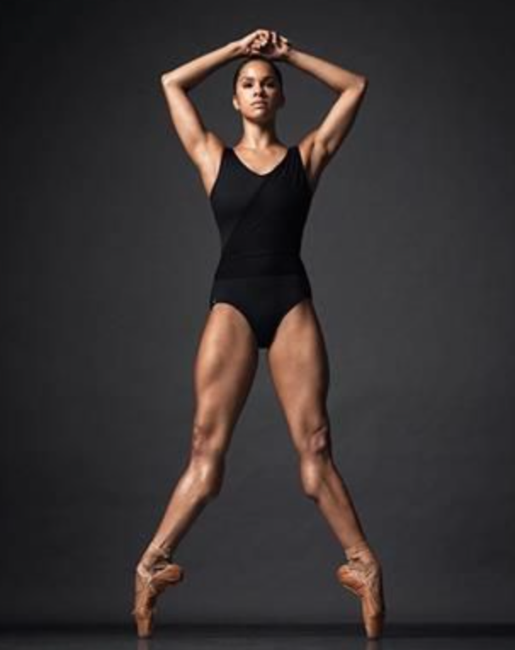

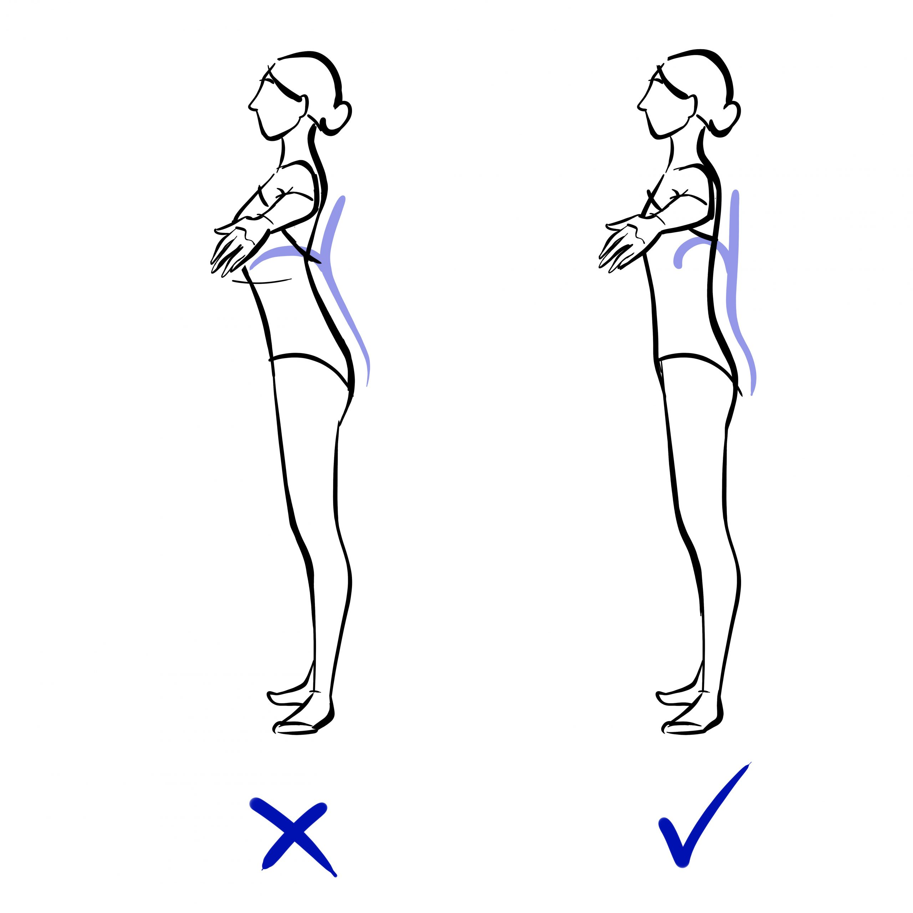

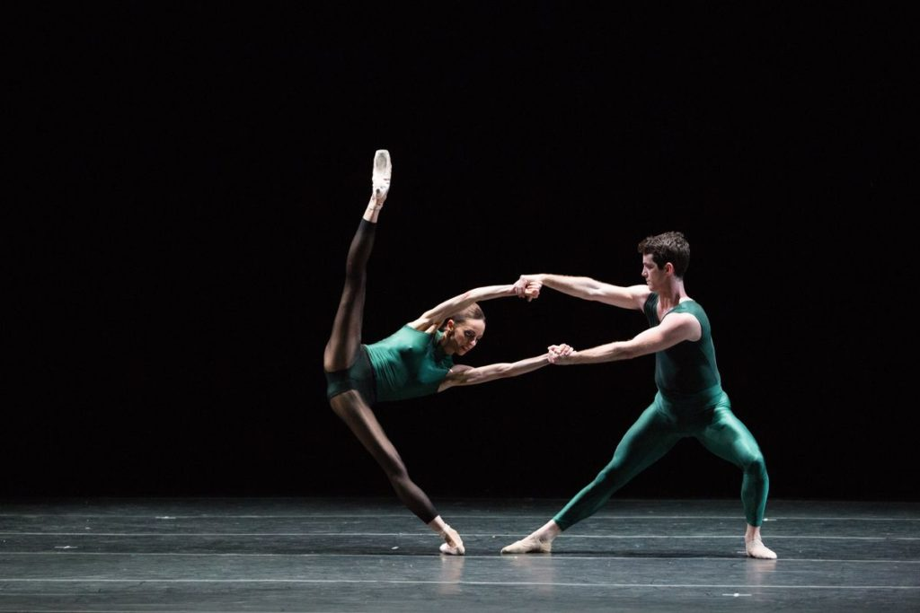

**5. Physical Skills**

Aspects enabling effective performance such as posture, alignment, balance, coordination, control, flexibility, mobility, strength, stamina, extension and isolation.

**7. Relationships**

The ways in which dancers interact; the connections between dancers.

|  |  |
| --- | --- |
| * Lead and follow | * Mirroring |
| * Action and reaction | * Accumulation |
| * Complement and contrast | * contact |
| * Formations |  |

**10. Space**

The ‘where’ of movement.

|  |  |
| --- | --- |
| * Levels | * Directions |
| * Pathways | * Patterns |

**9. Dynamics**

The qualities of movement based upon variations in speed, strength and flow.

|  |  |
| --- | --- |
| * Slow | * Fast |
| * Smooth | * Sharp |
| * Soft | * Rigid |

**8. Actions**

What a dancer does.

|  |  |
| --- | --- |
| * Gesture | * Turn |
| * Jump | * Travel |
| * Balance | * Fall |