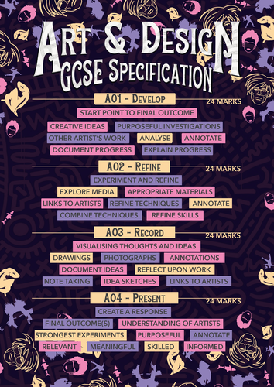

**GCSE ART, CRAFT AND DESIGN – KNOWLEDGE ORGANISER**

**Contents:**

1. Course structure
2. Assessment Objectives
3. Assessment Grid
4. Marking Spidergrams
5. Project Themes
6. Glossary of terms

**1 Course structure:**

The course consists of two components that total 100% of your mark.

This is a skills-based practical course; there is no written Exam.

All Coursework (Portfolio) and Exam work (Externally set assignment) measures how students have achieved the following assessment objectives:

• AO1: Develop ideas through investigations, demonstrating critical understanding of sources.

• AO2: Refine work by exploring ideas, selecting and experimenting with appropriate media, materials, techniques and processes.

• AO3: Record ideas, observations and insights relevant to intentions as work progresses.

• AO4: Present a personal and meaningful response that realises intentions and demonstrates understanding of visual language.

In Component 1 (portfolio) students develop responses to initial starting points, project briefs or specified tasks and realise intentions informed by research, the development and refinement of ideas and meaningful engagement with selected sources. Responses will include evidence of drawing for different purposes and needs and written annotation.

In Component 2 (externally set assignment) students respond to a starting point provided by AQA. This response provides evidence of the student’s ability to work independently within specified time constraints, realise intentions that are personal and meaningful and explicitly address the requirements of all four assessment objectives.

The course allows for the study of art and design in both breadth and depth. Portfolio projects, assignments or briefs can be open-ended or more narrowly focused. There is no restriction on the choice of media, scale or format that students use to reflect and evidence their submissions.

There is a similar approach to the choice and flexibility seen in the current externally set assignment papers, with the same number of starting points offered under each title. Some will be open in nature, others will have a greater degree of prescription.

The course has been designed to allow students to develop knowledge and understanding through a variety of learning experiences and approaches, including engagement with sources. This will allow students to develop the skills to explore, create and communicate their own ideas. Students will demonstrate these skills through the development, refinement, recording, realisation and presentation of their ideas through a portfolio and by responding to an externally set assignment.

You will be introduced to a variety of learning experiences which encourage the development of skills through the use of appropriate media, processes, techniques and technologies relevant to your chosen title(s) and area(s) of study.

You should demonstrate knowledge, understanding and skills in the development of your personal work, informed by first-hand experiences and appropriate secondary sources.

You must learn how sources inspire the development of ideas, drawing on the work and approaches of artists, craftspeople, designers, historical contexts, periods, societies and cultures.

**2 Assessment Objectives:**

AO1 –

You are expected to research the work of other artists, both historical and/or contemporary contexts.

Looking at others’ work is the starting point for every project. It is essential that you spend time looking at others’ work as this where your inspiration will come from. It is important to discover artists that you like to influence your own ideas. You are expected to develop ideas through investigations informed by selecting and critically analysing sources. You should understand the context of their work i.e., what inspired their work. You will learn how different sources inspire ideas.

AO2 –

You must provide evidence of drawing in both your portfolio submission and your externally set task. These can take different forms depending on the intention. It can feature as an element within the developmental process and/or explicitly in the realisation of intentions.

Drawing can be demonstrated in your evidence for AO1, AO2 and AO4, but **must** feature in your evidence for AO3. The significance of your drawing is determined by the ways in which it addresses purpose and need rather than the extent to which it demonstrates technical mastery.

AO3 –

When addressing the requirements of AO3, you must record your ideas, observations, insights and independent judgements both visually and through written annotation using appropriate specialist vocabulary, as work progresses. Annotation must be explicitly evidenced in both Component 1 and Component 2.

Your annotation should support the development of your own work, it should clearly communicate your intentions. Annotation should feature as an integral rather than ‘bolt-on’ aspect of the creative process.

AO4 –

You should produce an outcome for each project in your Portfolio and for your Externally set task – this will likely be a ‘final piece’ that realises your intentions through sustained application of the creative process.

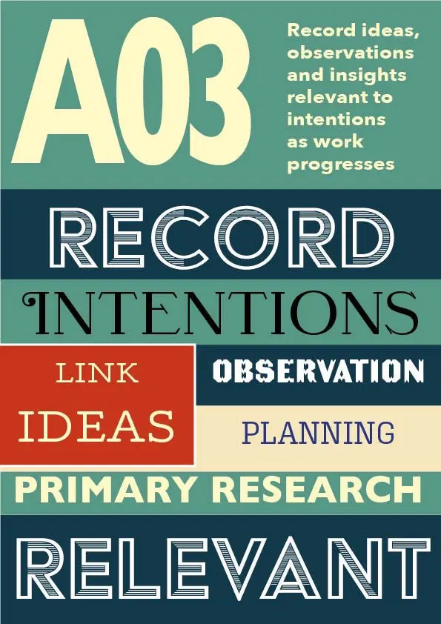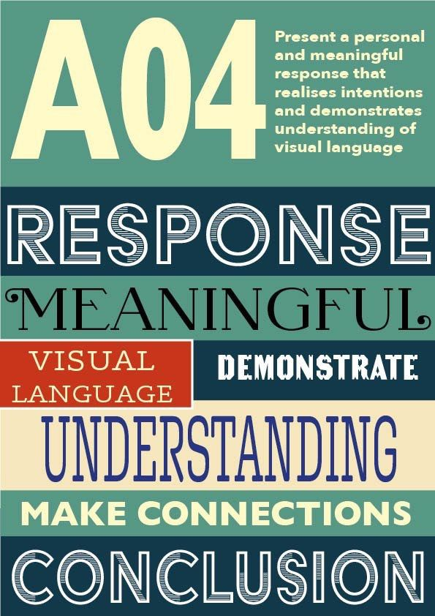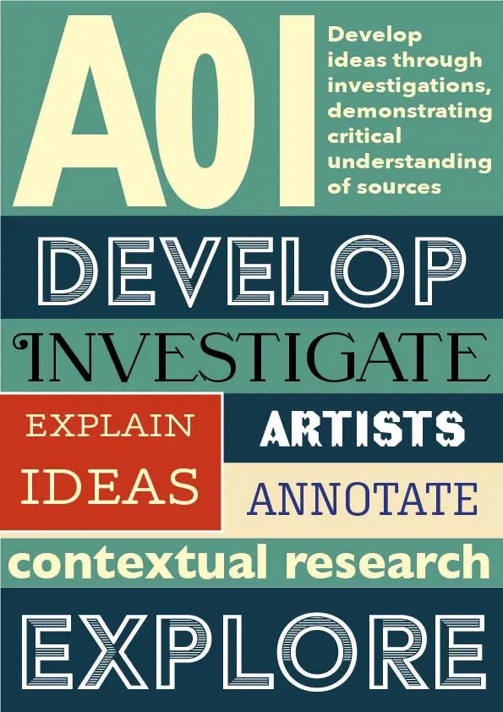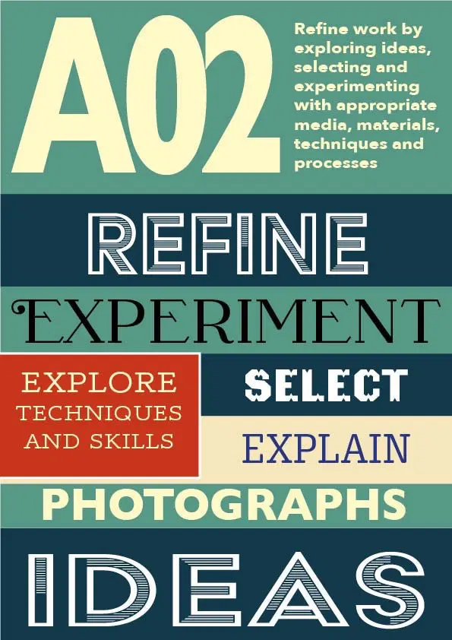

**3 Assessment Grid:**

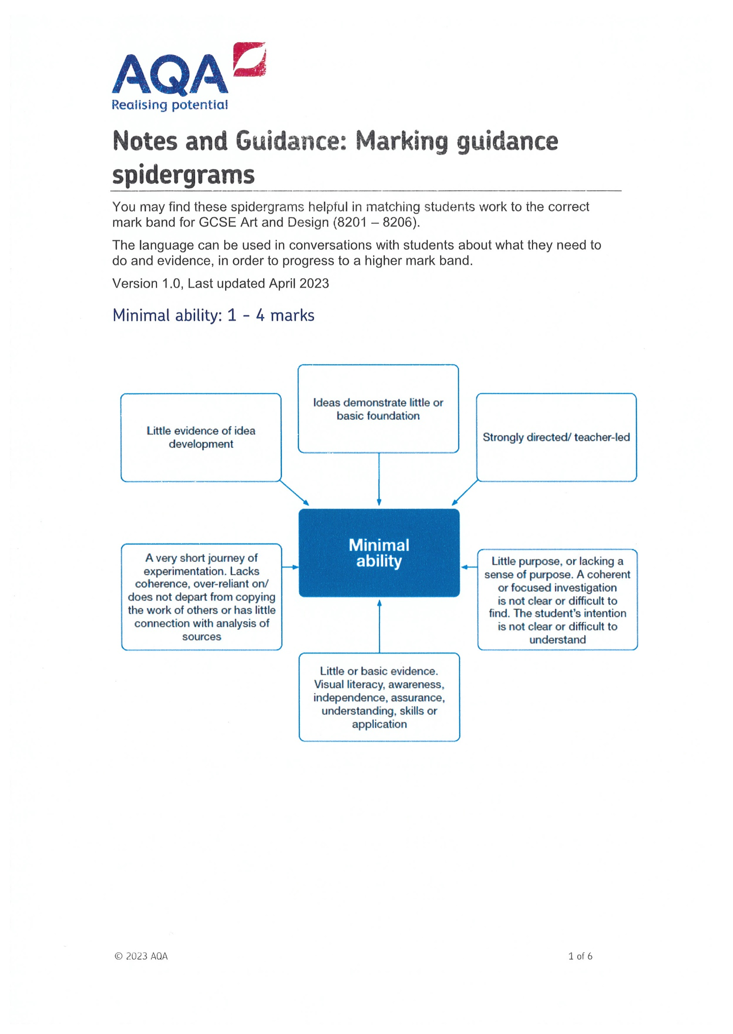**4 Marking Spidergrams:**

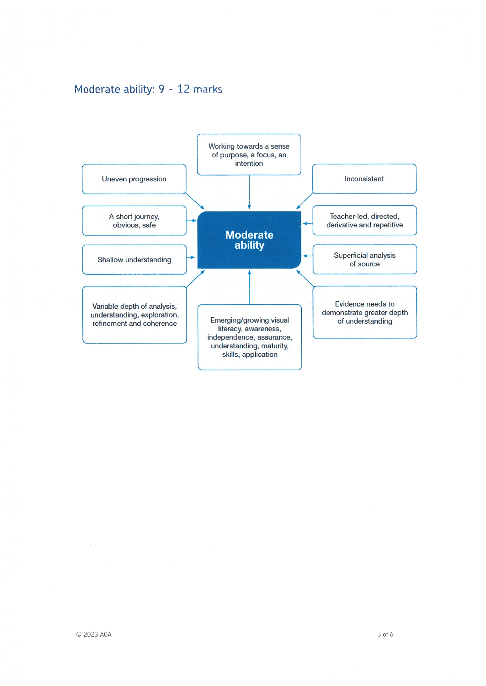

**5 Project Themes:**

Year 9: Day of the Dead (September – July)

This project explores the theme of the ‘Day of the Dead’ through drawing, painting, mixed media, and clay work. You will produce work to satisfy all assessment objectives, including 2D and 3D outcomes.

Year 10: Africa (September – July)

This project provides you with opportunities to explore ‘Africa’. You will have lots of freedom to focus your research on themes such as ancient civilizations, masks, endangered animals, slavery, tribal customs, clothing and jewellery. You will produce work to satisfy all assessment objectives, including 2D and 3D outcomes.

Year 11: Identity (September – Mock Exam in December)

This project explores the theme of ‘Identity’ through drawing, painting, and mixed media. You will produce work to satisfy all assessment objectives, including a 2D or 3D outcome.

Externally set assignment (January – April)

Externally set assignment papers are released in January and students complete a 10 – hour outcome in April/May over two days in the Art room.

**6 Glossary of terms:**

A

**abstract:** artwork where objects have been changed or modified so they no longer look realistic. An abstract work of art does, however, use a recognizable object or thing as its reference or origin.

**abstract expressionism**: a painting style developed in the 1940s and 1950s

in which artists applied paint freely to huge canvases to show feelings and emotions as opposed to realistic subject matter.

**academies:** arts schools started during the 1700s that represented the formal, accepted way of painting.

**acrylic paint:** a water-based paint with a polymer binder; dries to a permanent finish.

**additive process:** a sculptural process used with clay or other materials in which the image is built up instead of carved out.

**aerial perspective:** perspective or point of view achieved by using hue, intensity, and value to show distance on a flat surface; also called atmospheric perspective.

**aesthetics:** the study or theory of the beautiful in art.

**allegory:** the symbolic representation of truths about human traits and existence.

**alternating rhythm:** repeating motifs but changing the position, content, or spaces between them.

**analogous:** colours that are next to each other on the colour wheel and are related by a single hue; e.g., red, red-orange, orange, and red-violet.

**analyse:** to respond to an artwork by examining its features as they relate to the elements of art and principles of design.

**arabesque:** complex, intricate geometric design of stylized floral and plant motifs, often characteristic of some Islamic art.

**architecture:** three-dimensional art form that encompasses designing and planning buildings, bridges, cities, landscape, and bridges.

**armature:** basic structure on which to build a sculpture.

**art criticism:** the process and result of critical thinking about art; usually involves the description, analysis, and interpretation of works of art, as well as judgment or determination of the quality of the piece.

**artifact:** the material aspect of a culture; an object showing human workmanship or modification.

**artisan:** a worker in a skilled trade, especially a trade that involves making things by hand.

**artist statement:** information about context, explanations of process, descriptions of learning, related stories, reflections, or other details in a written or spoken format shared by the artist to extend and deepen understanding of his or her artwork; an artist statement can be didactic, descriptive, or reflective in nature.

**assemblage:** sculpture consisting of different objects and materials arranged in a unified 3-D composition.

**asymmetry:** a way of organizing the parts of a design so that one side differs from the other without destroying the overall balance and harmony; also called *informal balance.*

**atmospheric perspective**: the use of colour and value changes in painting and drawing to get the effect of distance.

B

**background:** the part of the **picture plane** that seems to be the farthest from the viewer.

**balance:** the principle of design that refers to the visual equalization of the elements in a work of art. The three major forms of balance are *asymmetrical balance* (where equilibrium is achieved by the balance differences in the art elements within a composition), *symmetrical balance* (where the art elements in a composition are balanced in a mirror-like fashion), and *radial balance* (a kind of balance where the elements branch or radiate out from a central point).

**baroque:** the period from 1580-1700 in Western arts that began in Rome as part of the Counter-Reformation (the Catholic Church’s efforts to revitalize in reaction to the Protestant Reformation); qualities associated with baroque art include dynamic movement, grandeur, vitality, and intensely warm colours.

**batik:** a method of dyeing cloth that originated in Indonesia; designs are created by coating the parts of the fabric not to be dyed with wax.

**binder:** a liquid that holds together the grains of pigment in paint.

**bust:** a portrait sculpture showing the subject’s head, shoulders, and upper chest.

**Byzantine**: in art, the term refers to a style from the Middle Ages (500-1450) associated with the Eastern Roman Empire and its capital, Byzantium (later Constantinople); paintings and mosaics are characterized by rich colours and Christian icons*.*

C

**calligraphy:** decorative or fine handwriting generally created with a quill, pen, or brush.

**canvas:** linen or cotton cloth tightly stretched over and attached to wooden stretcher bars to create a taut surface for oil or acrylic painting.

**capital:** the top element of a pillar or column; in Greek architecture, the style of the column was reflected in the capital. *(Above, Ionic, Corinthian, and Doric capitals.)*

**carving:** shaping wood, stone, or marble by scraping, cutting, and chipping.

**casting:** the process of pouring melted metal or other liquid into a mould to harden.

**ceramics:** the process of creating functional and non-functional artforms out of clay.

**ceremonial art:** art made to commemorate an event or the life of a person or to be used as part of a ritual or celebration.

**chalk:** pigments mixed with gum and pressed into a stick form to be used as crayons.

**charcoal:** compressed, burned wood used for drawing.

**chiaroscuro:** using the contrast and transitioning of light and dark areas to create the illusion of three-dimensional form on a two-dimensional surface.

**classicism:** imitating, referencing, or having the general characteristics of the art and culture of ancient Rome or Greece. Classical characteristics include idealized beauty, restraint, harmony, and balance.

**clay:** earth mixed with water so that it can be shaped and fired to create permanent artwork.

**collage:** artwork made by attaching pieces of paper or other materials to a flat surface.

**colour:** the quality that is observed when light strikes a surface and is reflected to the eyes; different wavelengths of light create different colours; colour is described in terms of **hue, intensity**, and **value.**

**colour groups:** groupings of colours with a particular hue; sometimes called *colour families.*

**colour harmonies:** colour groupings that have a pleasing visual effect (as opposed to colours that clash with one another).

**colour properties:** hue (the colour name), intensity (the purity and strength of the colour), and value (lightness or darkness of the colour).

**colour scheme**: the choice of colours used in a design or artwork.

**colour wheel:** a tool for organizing colour that shows the visible light spectrum organized in a circular format; a tool that helps to chart the relationships between colours (hues). On a colour wheel, the **primary colours** of magenta red, yellow, and cyan (turquoise) blue are the fundamental hues from which other colours can be mixed. For instance, mixing combinations of two of the primary colours results in the **secondary colours** of green, purple, and orange. Similarly, the mixture of a primary colour and a secondary colour can result in the creation of **tertiary colours**such as yellow-orange or blue-green. These relationships, as well as the concepts of **warm/cool colours** and **analogous colours,** are easily illustrated on the colour wheel chart.

**complementary colours:** pairs of colours that are opposite one another on the colour wheel. Red and green, blue and orange, and yellow and violet have the greatest degree of contrast. These pairs are also complementary colours: red-violet and yellow-green, red-orange and blue-green, and yellow-orange and blue-violet.

**composition:** the arrangement of the elements of art and the principles of design within a given work of art.

**computer design:** any visual expression (original art, functional graphics, scientific illustrations) created with a computer.

**conceptual art:** an art movement that arose in the 1960s insisting that the concept or idea is more important than the finished artwork; often the creative process is documented in some way.

**contemporary art:** artwork from the mid-1900s to the present characterized by experimental media and techniques; it often reflects the diversity of society and the blending of cultures as well as comments on society.

**contour drawing:** a continuous line drawing where the student draws the interior and exterior contours of the subject. In the process, students keep their eyes on the contours of their subject more than they do on their drawing, and the results are drawings that are often randomly abstracted or distorted.

**contrast:** design principle that emphasizes differences between the art elements. For example, a painting may have bright colours that contrast with dull colours or angular shapes that contrast with rounded shapes. Sharp contrast draws attention and can direct a viewer to a **focal point** within a work of art.

**cool colours:** a colour group associated with blue that includes blue-green, blue-violet, green, yellow-green, and violet. Cool colours appear to recede in space and have a general psychological association with coolness.

**craft:** an occupation or trade requiring manual dexterity or skills; in visual arts a fine craft is a functional or decorative object—such as a piece of furniture, quilt, or basket—created by hand by a trained artisan.

**crayon:** a wax stick containing pigment; used as a two-dimensional medium.

**cross-hatching:** superimposing parallel lines (**hatching**) in opposite directions to indicate shading in drawings and prints.

**cubism:** an art movement from 1910-1920s in which artists tried to show all sides of three-dimensional objects on a flat surface; subject matter is broken up and reassembled in abstract form.

**culture:** the customs, beliefs, arts, and way of life of a specific group of people.

**curate:** collect, sort, and organize objects, artworks, and artifacts; preserve and maintain historical records and catalogue exhibits.

**curator:** person responsible for acquiring, caring for, and exhibiting objects, artworks, and artifacts.

D

**depth:** the actual dimension of depth within a work of art or the illusion of showing distance in a work of art.

**describe:** to respond to an artwork by stating facts about objects and art elements present in a work; it also refers to when, where, and by whom the work was done.

**design:** plan, organization, or arrangement of elements in a work of art.

**digital art:** art in electronic form including photos, images, video, audio files, or artwork created or presented through electronic means; a gallery of artwork viewed electronically through any device.

**dimensional:** measurement in one direction. A two-dimensional (2-D) work of art has the two dimensions of length and width; a three-dimensional (3-D) work of art has the three dimensions of length, width, and depth.

**dome:** in architecture, a hemispherical ceiling over a circular opening.

**drafting:** the technique of creating a technical drawing used by architects, designers, or engineers; a draftsman is someone who specializes in making technical drawings.

**drawing:** a two-dimensional artwork made with a dry medium such as pencil, charcoal, or crayon.

E

**elements of art:** the basic components or tools of visual communication; include line, space, shape/form, value, colour, and texture.

**embroidery:** decorating fabric with stitches.

**emotionalism:** a theory of art that places emphasis on the expressive qualities; the most important thing about a work of art is the communication of moods, feelings, and ideas.

**emphasis:** the principle of design that is concerned with dominance; the development of a main idea or centre of interest (**focal point**).

**encaustic:** a painting technique using pigments dissolved in hot wax.

**engraving:** a printing method in which a design is cut into a material, usually metal, with a sharp tool, and the surface is inked to make a print.

**environmental art:** sculpture or structures designed to envelope the viewer, who is invited to enter or walk through it.

**environments:** term for installation art, mixed media works, or assemblages; works in which three-dimensional objects are introduced into two-dimensional works; or works that represent multimedia full-scale models of everyday things and real-life situations.

**etching:** a printing method that involves placing a metal plate in acid to cut the lines used for the image; a print is made when the plate is inked.

**expressionism:** a style of art falling between realism and abstraction, in which the artist tries to capture not what the observed world looks like but the emotional or intellectual response it evokes in the artist; many different types of works can be described as expressionistic, from recognizable but exaggerated depictions of scenes or figures to nearly abstract forms.

**expressive:** a purpose for making art; art to communicate emotions and feelings.

F

**fabric:**a material produced by interlocking horizontal and vertical threads.

**facade:**the front or face of a building.

**fibre art:** a type of art using fibres, yarn, and fabric as the medium to create tactile forms and images through surface design, weaving, and construction techniques.

**fibre:** a type of art using fibres, yarn, and fabric as the medium to create tactile forms and images through surface design, weaving, and construction techniques.

**fibres:** natural or synthetic filaments, such as cotton or nylon, which can be used in the construction of textiles.

**figurative:** a term to describe artwork representing the form of a human, animal, or thing.

**figure:** the form of a human, animal, or thing; most often refers to an entire human form.

**fine art:** works made to be enjoyed, not functional, and judged by the theories of art.

**fire:** to apply heat to harden clay.

**focal point:** the area within a composition at which the emphasis is greatest and where the eye of the viewer continually comes to rest (the centre of interest).

**folk art:** artworks created by individuals who have little or no formal academic training in fine art.

**folk craft:** an object created by an individual working within a group or within a regional, informally transmitted tradition; the object may have aesthetic or artistic qualities.

**folklore:** the artistic and cultural traditions (such as customs, beliefs, technical skills, crafts, arts, rituals, and oral traditions) shared by a group of people and maintained over time; also called folklife. Folk groups can be defined by a wide variety of factors such as occupation, recreation, religion, ethnicity, or geography.

**foreground:** the part of a picture which appears closest to the viewer and often is at the bottom of the picture.

**foreshortening:** a way of drawing figures or objects according to the rules of perspective so they appear to recede or protrude into three-dimensional space.

**form:** element of art that refers to the three-dimensional quality/qualities of an artwork (length, width, and depth) and encloses volume; they can be created in 3-D art or implied in 2-D art by using shading and highlights.

**formalism:** a philosophical approach to art that is primarily concerned with the effective organization of the elements of art and principles of design.

**found objects:** common or unusual objects that may be used to create a work of art; specifically refers to scrap, discarded materials that have been “found” and used in artworks.

**fresco:** a method of painting in wet plaster so that the artwork becomes part of the wall upon which it is painted.

**functional art:** functional objects such as dishes and clothes that are of a high artistic quality and/or craftsmanship; art with a utilitarian purpose.

G

**genre:**category of art or design identified by similarities in form, subject matter, content, or technique.

**gesture drawing:**a sketch made with relatively loose arm movement (or gestures), often as a warmup or to block in the basic shapes of a composition.

**glass:**an art medium made of silicone and other trace elements that can be formed when hot or used in mosaics and stained-glass windows when cool.

**glaze:**a thin coating of minerals applied to ceramicware to produce a coating and to make the surface smooth and waterproof.

**Gothic:**a style of architecture from the 1100s to 1600 featuring pointed arches, flying buttresses, and stained-glass windows.

**gouache:**opaque, water-based paint that dries to a dense matte finish.

**gradation:** principle of design that refers to the use of a series of gradual/transitional changes in the use of the elements of art in an artwork; for example, a transition from lighter to darker colours or large shapes to smaller ones.

**graphic design:** visual communication intended to be used with commercial printing/reproductive processes in both two- and three-dimensional presentations.

**grid:** pattern of intersecting vertical and horizontal lines.

**gouache:** opaque water-based paint that dries to a dense matte finish; similar to the appearance and quality of poster paints.

H

**hard-edge painting:**an art movement that began in the late 1950s and early 1960s in which the edges of shapes are crisp and precise rather than blurred.

**harmony:**a principle of design that refers to combining similar elements in an artwork to accent similarities.

**hatching:**parallel lines that indicate shadow in prints or drawings.

**horizon line: t**he line in an artwork where the water or land ends and the sky begins.

**hue:** the property identifying the dominant **colour group** of a colour; for example, distinguishing between a colour that is more red-orange than red-violet is referencing the property of hue.

I

**iconography:** the study of the meaning of visual images, whether conveyed directly or symbolically.

**imitationalism:** a theory of art that places emphasis on literal qualities; in this theory, the most important thing about a work of art is the realistic representation of subject matter.

**impasto:** paint applied very thickly to make a textured surface.

**impressionism:** art movement emerging in the late 1860s that focused on the use of spontaneous, unblended brushstrokes of vibrant colour to capture transient effects of light. The artists looked to the life around them as the inspiration for their paintings of sunlit landscapes, middle-class people at leisure, and mothers with children. The many inventions of the industrial revolution included portable oil paints and easels that allowed the artist to break free of the studio and paint *en plein air* (out of doors), or from sketches done directly on the spot.

**impressionistic:** an artwork style that shows the effects of light and atmospheric conditions spontaneously captured at a moment in time.

**ink:** a two-dimensional medium or pigment mixed with water and chemicals to be used for drawing.

**installation:** an expansion of **environmental art** into room-size settings; an installation is created for a specific space and may be permanent or temporary, with temporary installations experienced primarily through documentation.

**intensity:** the property of colour that refers to the brightness or dullness of a colour; how pure the colour is.

**intermediate colours:** colours created when a primary colour is mixed with a secondary colour to create another colour, such as red-violet, blue-green; also called **tertiary colours**.

**interpret:** to respond to artwork by identifying the feelings, moods, and ideas communicated by the work of art. Interpretation also calls for the investigation of the influence of time and place upon the artist who created the work of art.

K

**kiln:** a furnace in which clay is fired.

L

**landscape:** a subject matter category in which the main theme of the work is natural scenery such as mountains, valleys, trees, rivers, and lakes. Traditionally, the space depicted in a landscape is divided into three parts. The **foreground** is the part closest to you, the viewer. Objects in the foreground are usually larger and more detailed than other objects; they overlap other objects. Objects in the **middle ground** appear to be behind objects in the foreground. The **background** is the part of the painting farthest from the viewer. Objects in the background are usually smaller and less distinct than other objects in the work.

**line:** element of art which refers to the mark(s) made on a surface by a moving point. The element of line has a wide range of qualities and expressive possibilities: curved lines, diagonal lines, dotted lines, straight lines, etc.

**lineage-based cultures:** cultures found in many areas of the world that rely on an oral tradition along with governing powers assigned to a powerful leader and his or her offspring.

**linear perspective:** a type of perspective used by artists in which the relative size, shape, and position of objects are determined by drawn or imagined lines converging at a point on the horizon.

M

**mat:** to frame a picture or drawing with a cardboard border. The “mat” used in matting an artwork can be made of cardboard, acid-free papers, or archival cotton fibres.

**media:** the materials used by the artist to produce art (i.e., paint, clay, fibres); the singular is medium.

**medieval art:** European art of the Middle Ages (800-1400) created to instruct in the Catholic faith; works appealed to the emotions and stressed the importance of religion.

**metal:** three-dimensional media used to make sculpture, e.g., bronze, copper, steel, tin, and aluminium.

**middle ground:** area in a picture between the **foreground** and the **background**.

**mimetic:** artwork whose purpose is to “mimic” or imitate nature; often refers to work that is highly realistic.

**minimalism:** an art movement of the 1960s reducing art to that which is intrinsic to its medium and eliminates what is not.

**mixed media:** any artwork that uses more than one medium.

**mobile:** a hanging sculpture that has free-moving parts.

**model:** a three-dimensional representation of a person or thing or of a proposed structure, typically on a smaller scale than the original; also, a person who poses for an artist.

**modernism:** (late 1800s to the early 1970s) an art movement in which artists focused on individual style and artistic process rather than reproducing the world as it appears visually. This focus led many modern artists toward more abstract art. Modernism is a larger heading under which art movements such as impressionism, fauvism, expressionism, cubism, Dadaism, surrealism, and abstract expressionism all flourished in succession.

**monochromatic:** a colour scheme that uses one colour and all the tones, tints, and shades that can be derived from it.

**mosaics:** artworks made with small pieces of coloured glass or tile set in concrete.

**motif:** an image, pattern, or theme repeated to create visual rhythm.

**movement:** the design principle that uses some of the elements of art to produce the appearance of action in an artwork or to cause the viewer’s eye to sweep over the artwork in a certain manner.

**mural:** surface treatment or decoration that is applied directly to a wall. A painted fresco is one form of a mural.

N

**narrative artwork:** a work of art whose primary purpose is to tell a story.

**naturalism:** an art movement of the 1800s advocating the realistic depiction of objects in a natural setting.

**naturalistic:** artwork that looks like the subject it is trying to represent.

**negative space:** the areas of space that are in and around the subject matter. The negative spaces define the subject matter.

**neoclassicism:** (late 1700s and early 1800s) “new” classicism movement inspired by the classical style of ancient Greece and Rome, and the classical ideals of harmony, idealized realism, clarity, and reason are found in examples of neoclassical architecture, painting, and sculpture.

**neutral colours:** colours that are neither warm nor cool, such as black, white, grey, and brown. Some neutral colours may be achieved by mixing a complementary colour pair—which “neutralizes” them.

**non-objective/nonrepresentational:** artwork that contains no recognizable objects or forms.

O

**oil paint:** slow-drying paint made of pigments mixed with an oil; usually opaque and used on canvas.

**oil pastels:**a type of**pastels** that have an oil base and more brilliant colour.

**one-point perspective:** a form of **linear perspective** in which all lines appear to meet at a single point on the horizon.

**op art:** a 20th century art style in which artists try to create an optical illusion on a flat surface.

**organic shapes:** irregular shapes that might be found in nature (as opposed to geometric shapes).

**overlapping:** a means of conveying the illusion of depth by having one thing overlap, or partly cover, another.

P

**paint:**a pigment suspended in liquid with a binder.

**painterly:**a painting technique in which forms are created with patches of colour rather than with hard, precise edges.

**painting:**a two-dimensional artwork made using wet media such as tempera, oil, or watercolour.

**palette:** a thin board used by painters to hold and mix their colours; also refers to the specific range of colours used by an individual painter or used in specific circumstances.

**paper:**a material made from plant pulp such as cotton, wood, flax, and papyrus that is used as a surface for drawing and painting.

**papier-mâché:** sculpture medium that uses paper or rags dipped in wheat paste (wallpaper paste) over an **armature**.

**pastels:** pigments pressed into sticks and used as a dry medium on paper; sometimes referred to as hard or soft *chalk pastels.*

**pattern:** repetition of an element of art (i.e., shapes, lines, or colours) to achieve decoration or ornamentation.

**pencil:** a two-dimensional medium made using graphite or other pigments contained in a stick-like drawing device.

**perspective:** system of representing three-dimensional objects on a two-dimensional surface, giving the illusion of depth in space. **Linear perspective** deals with drawing, and **atmospheric perspective** uses colour and value changes to get the effect of distance.

**persuasive:** a purpose of art in which the intent is to move, or persuade, the viewer to a belief, position, or action; includes advertising, marketing, and propaganda.

**photography:** the art, craft, and science of capturing optical images on light-sensitive surfaces.

**photomontage:** a collage made up of fragments of photographs, newsprint, and other items; a photograph in which prints in whole, or part are combined to form a new image.

**picture plane:** in perspective, the plane (flat level) occupied by the surface of the picture.

**pigment:** finely ground powder that gives paint its colour.

**plaster:** a mixture of powder gypsum and water that hardens to a smooth, solid medium for sculpture; plaster can be carved, cast, or attached to another surface.

**pop art:** art style that emerged in the mid -1950s that portrays images of popular culture (such as soup cans and comics) as fine art.

**portrait:** subject matter category in which the main purpose of the artwork is to communicate a likeness of an individual or group of individuals.

**positive space:** the primary subject matter in a work of art, as opposed to the background or unoccupied spaces.

**post-impressionism:** a French art movement of the 1890s in which artists reacted to impressionism with a style showing a greater concern for structure and form.

**pottery:** objects made from fired clay, including earthenware, stoneware, and porcelain.

**primary colours:** hues that cannot be produced by a mixture of other hues: magenta red, yellow, and cyan (turquoise) blue.

**principles of design:** concepts for combining the elements of art into successful art forms, including balance, contrast, emphasis, movement, pattern, repetition, rhythm, proportion, unity, and variety.

**printmaking:** the process of reproducing images on a flat surface; three types are relief block (linoleum, wood), intaglio (etching, engraving), and stencil (silkscreen).

**processes:** both art methods and the media used for visual communication in a variety of art forms.

**proportion:** the relationship in size of one component of a work of art to another.

**purposes of art:** reasons that people made art.

Q

**quilt:** a fibre work consisting of layers of cloth held together by decorative stitching; can be created as functional or fine art.

R

**radial balance:**balance in which the elements branch out from a central point.

**random rhythm:** visual rhythm in which a motif is repeated in no apparent order.

**realism:** art movement that emerged in the 1840s in which artists focused attention on ordinary people, such as peasants and laborers, who had not been pictured in art up to that time. Realists depicted real scenes from contemporary life, from city street scenes to country funerals. They tried to show the beauty in the commonplace, refusing to idealize or gloss over reality as neoclassical and romantic artists had.

**realistic:** artwork that attempts a photographic likeness of the subject matter; sometimes refers to the choice of subject that is commonplace as opposed to courtly and idealized.

**regular rhythm:** visual rhythm created through repeating the same motif with the same distance between placements.

**relief printing:** a type of printmaking in which the image to be printed is raised from the background.

**relief sculpture:** three-dimensional forms attached to a background.

**Renaissance:** literally means “rebirth.” The Renaissance period in Europe lasted from 1300-1600 and was distinguished by a renewed interest in the art, architecture, literature, and philosophy of ancient Rome and Greece. The Renaissance began in Italy and eventually spread to other areas of Europe, laying the intellectual and cultural groundwork for the modern world.

**repetition:** a way of combining art elements so that the same elements are used over and over to achieve balance and harmony.

**representational art:** artworks that depict the visual appearance of objects and things.

**rhythm:** in visual art, the use of art elements to produce a visual tempo or the feeling of a regular beat or movement.

**ritual:** a purpose of art that includes celebration and commemoration.

**Romanesque**: (1000-1200) a style of architecture characterized by round arches, small windows, thick walls, and a solid appearance.

**romanticism:** (late 1700s to early 1800s) an art movement that emphasized passionate emotion and artistic freedom. The romantics had a deep fascination with historical literature and artistic styles that stood in contrast to a world that was increasingly industrialized. The romantics’ artistic approach was, in part, a rejection of the classical artistic values of the neoclassical movement. Rather than finding their artistic guidance in the classical principles of harmony, idealized realism, or clarity, the romantics sought inspiration from intense personal experiences.

S

**sculpture:**the art process of modelling, carving, or joining materials into a three-dimensional form.

**secondary colours:** violet, green, orange; hues that can be produced by mixing two of the primary hues. Magenta red and cyan (turquoise) blue make violet. Yellow and cyan blue make green. Magenta red and yellow make orange.

**self-portrait:** a portrait an artist makes of their own likeness.

**shades:** colours created when black is added to a hue to darken a colour.

**shape:** element of art that refers to an enclosed area of 2-D or 3-D space that is defined by its external edge. Almost everything you see has one main shape. A shape can be created within an artwork by enclosing an area with a line, or it can be achieved by making changes in value, colours, forms, or one of the other elements of art.

**space:** element of art that refers to the perceived distance or area between, around, above, below, or within a given area. Artworks can deal with actual physical space or the illusion of space (depth), depending on the aims of the artist; major divisions within the composition of an artwork include areas of positive and negative space.

**still life:** the subject matter category in which the main purpose of the artwork is to show inanimate objects.

**stone:** a natural material used to make sculpture such as limestone, marble, soapstone, or jade; this medium uses the **subtractive process** of carving.

**style:** a characteristic manner of presenting ideas and feeling in visual form; may also refer to an individual artist or a group of artists whose work has certain features in common.

**subject matter:** iconography, or what an artwork depicts.

**subtractive process:** the sculptural process that requires carving away material to form an image.

**surrealism:** an art style that began in the 1920s in which dreams and fantasy served as subject matter for artworks.

**symbolic:** works of art that have forms, images, or subjects representing meanings other than the ones with which they are usually associated.

**symmetry:** a way of organizing the parts of a design so that one side duplicates or mirrors the other.

T

**tempera paint:** water-based paint that traditionally had pigment mixed with an egg binder. Sometimes called poster paint, this opaque medium now has a chemical binder.

**tertiary colours:** red-violet, red-orange, yellow-orange, yellow-green, blue-green, blue-violet; colours that can be created by mixing a primary and a secondary colour. The tertiary colours fall between primary and secondary colours on the colour wheel.

**textiles:** artworks that are created from natural or man-made fibers. Weaving, basketry, stitchery, and knitting are a few of the processes involved in textile design.

**texture:** element of art that refers to the perceived surface quality or “feel” of an object—its roughness, smoothness, softness, etc. Artworks can deal with the actual physical texture of a surface or the illusion of texture, depending on the aim of the artist.

**three-dimensional:** artwork with length, width, and depth; the form is sculptural and meant to be viewed from more than one angle.

**tints:** colours obtained by adding white to a hue to lighten it.

**tones:** colours obtained by adding grey to the hue of a colour.

**tradition:** the handing down of information from one generation to another, generally by word of mouth or example.

**transition:** the principle of art that refers to a way of combining art elements by using a series of gradual changes in those elements (**gradation**).

**triadic:** a colour group or colour scheme using three colours of equal distance from one another on the **colour wheel**, forming an equilateral triangle. Red, yellow, and blue form a triadic colour group.

**two-dimensional:** artwork with length and width, usually a flat or nearly flat surface that is intended to be viewed only from the front.

**two-point perspective:** **linear perspective** in which all lines appear to meet at either of two points on the horizon.

U

**unity:** refers to the visual quality of wholeness or oneness that is achieved through effective use of the elements of art and principles of design.

V

**value:** element of art that refers to the degree and qualities of lightness or darkness. In colour theory, value refers to the lightness (**tint**) or darkness (**shade**) of a colour, i.e., pink is a tint of red.

**vanishing point:** in perspective drawing, a point or points on the horizon where receding parallel lines seem to meet.

**vanitas:** a theme in paintings that emerged in the 1600s in Holland featuring symbolic representations of the fleeting nature of life and a reminder that spiritual redemption should be at the centre of a person’s life. A typical symbol in a vanitas painting would be the human skull, but other symbols, such as a disordered pile of dishes or books, hint at the foolishness of a life focused on earthly concerns versus one focused on the soul’s redemption.

**variety:** quality achieved when the art elements are combined in various combinations to increase visual interest. For instance, an assortment of shapes that are of a variety of sizes attracts more attention than an assortment of shapes all the same size.

**vault:** in architecture, an arched roof or covering of masonry construction.

**volume:** the space within a form; in architecture it refers to the space within a building.

W

**warm colours:** a colour group associated with red that includes red-orange, red-violet, orange, yellow-orange, and usually yellow. Warm colours appear to move forward in space and have a general psychological association with warmth.

**wash:** a thin layer of translucent colour or ink used in watercolour, brush painting, and, occasionally, oil painting.

**watercolour:** transparent water-based paint that uses gum arabic as a binder.

**weaving:** fibre construction predicated on a right-angle relationship. In a weaving, the warp is a unit of strong taut cords running vertically on a loom, and the flexible weft fibres are “woven” in and out horizontally of the warp strings. When the weaving is completed, the warp strings are cut from the loom, and warp and weft fibres have created a solid piece of woven cloth.

**wood:** a natural material used to make sculpture using the **subtractive** process (although some wood sculpture is constructed using pre-cut pieces of wood).

Y

**yarn:** a material produced by twisting fibres of animal, plant, or synthetic sources, used to make fibre art.