Component 3 Islam – Beliefs & Teachings
Key words
Tawhid (oneness) - The basic Muslim belief in the oneness of God.
Prophethood (Risalah) – The term used of the messengers of God, beginning with Adam and ending with the Prophet Muhammad.
Halal (permitted) – Actions or things which are permitted within Islam, such as eating permitted foods.
Haram (forbidden) – Any actions of things which are forbidden within Islam, such as eating forbidden foods.
Mosque (Masjid) – A ‘place of prostration’ for Muslims, it is a communal place of worship for a Muslim community.
Shari’ah (Straight path) – A way of life; Muslims believe God has set out a clear path in Qur’an/Hadith for how Muslims should live.
Ummah (Muslim community) – Refers to the worldwide community of Muslims who share a common religious identity.
Islam – submission or peace
Qu’ran –(reading or recitation). Revealed to Prophet Muhammad as a ‘living sound’ and it must be spoken to reveal its beauty and truth.
Sunnah – The record of all Muhammad said and did; which helps guide Muslims today to live Allah pleasing life.
Hadith – collections of the recorded sayings of the Prophet Muhammad.
Sunni – one who follows the Sunnah.
Shi’a – ‘from the house of Ali’. Ali – 4th Caliph and relative of Prophet.
Imam – for Sunnis – leader of a congregation in mosque. For Shi’a – 12 Imams – holy figures, divinely appointed descendants of Muhammad.
Allah – Arabic word meaning God. Muslims believe they worship the same God that spoke through Musa (Moses) and Isa (Jesus).
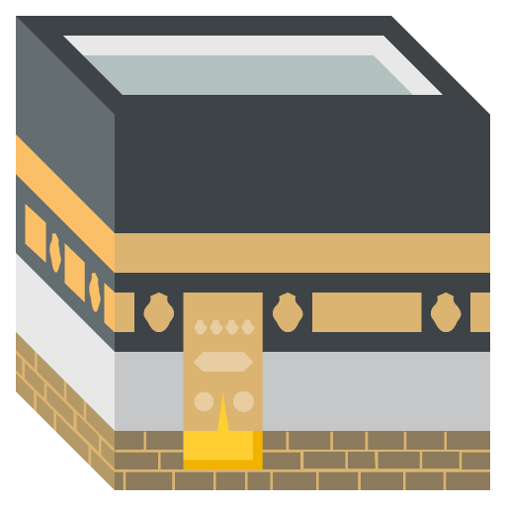
Shirk – Associating other beings or things with God.
Revelation – A message sent by God and revealed or shown to the human mind. E.g. Quran.
Fitrah – natural instinct of all humans, from birth, to know and worship God.
Hanifs – people who lived in Arabia before the Prophet Muhammad and who believed in one God.
Rasul – messenger of God (few). Nabi – Prophet of God (many). E.g. Prophet M was Nabi & Rasul.
Ka’ba – House of God, black covered cube building in centre of holiest mosque in Mecca.
Mahdi – long awaited saviour who will come to rescue the world. (For Shi’a – Mahdi is 12th Imam)
Barzakh – a place of waiting, after death until the day of judgement
Niyyah – the honest intention to worship God.
Al Qadr – destiny, nothing takes place purely by chance. God knows and wills all future events.

Islam | Qur’an | Sunnah / Hadith
  Islam means submission in Arabic. Allah is the creator and has revealed himself through history to many peoples through prophets. God’s final and greatest revelation comes in the form of the Qur’an to Prophet Muhammad. 1.6 billion Muslims worldwide – 2nd largest religion. 4.5% of UK is Muslim. | Most important source of authority for Muslims. Complete and perfect book of guidance for all humans. Revealed by God to Prophet Muhammad through Angel Jibril. Written in Arabic and final compilation by Caliph Uthman shortly after Prophet’s death (632AD). Unchanged and literal word of God. Qur’an is known as Umm-ul-Kitab ‘Mother of Books’. Qur’an is a sacred and holy text which is free from distortion unlike other holy books. Qur’an has always existed and was written in Arabic on tablet of stone in heaven. Qur’an is guide for life, teaches everything, learn by heart in Arabic. | 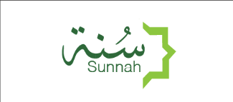  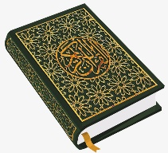  Sunnah is the inspiration of the life of the Prophet. His life is an example and a guide for all Muslims. 2nd most important source of authority. Muslims know about Sunnah largely through the Hadith. Hadith are many books containing the sayings and actions of the Prophet recorded by family and companions.
Shariah | Ummah - Sunni / Shi’a | Sunni/Shia Differences
Shariah uses Islamic sources of authority (Qur’an, Hadith). Sets out moral and religious rules that Muslims must follow. Shariah is incorporated in the law in many Muslim majority countries. Shariah defines what is halal and what is haram. Shariah covers many everyday issues –food, clothing, crime, money, sex and relationships.  E.g. It is Haram to murder, drink alcohol, cohabit. It is Halal to eat chicken (halal) and vegetables.  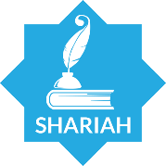 | The Ummah is the worldwide community of Muslims. All Muslims are equal, whatever, language, race or nationality. ‘All people are equal as the teeth of a comb.’ Hadith. There are many denominations (types) within Islam. The largest two are Sunni and Shi’a. 87-90% of Muslims are Sunni. 10-13% are Shi’a (mostly Iran). Sunnis & Shi’a share most beliefs but have some significant differences in understanding, laws and practices.  Split - Shias believe first Caliph (leader) should have been Ali but Sunnis believe it should have been Abu Bakr. Sunnis believe Muhammad said Abu Bakr should be Caliph but Shi’a dispute that since Ali was a relative it should be inherited. Husayn, Ali’s Son, should have been next in line but was murdered by Sunni ruler at Battle of Karbala.  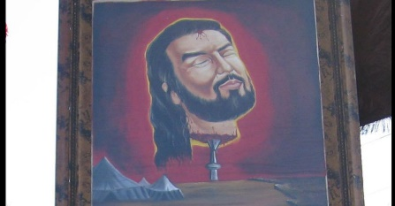  Husayn was beheaded and is mourned by the Shi’a. | Sunnis | Shias
 |  | Religious guidance only from Qur’an & Hadith.  No religious hierarchy – no Imams appointed by God.  Caliph should come from companions not relatives | God guided Prophet to appoint Ali.  Leadership of Muslim community is continued through 12 Imams – divinely appointed from Prophet’s relatives.  Last (12th) Imam will appear at end of world as Mahdi (chosen one)
 |  | Six Beliefs
 |  | 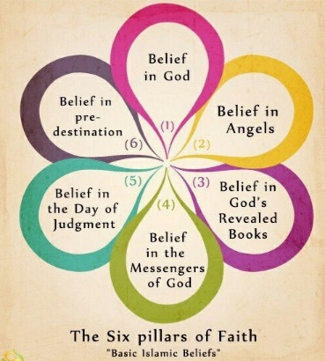
1. Allah (Tawhid) | 2. Malaikah (angels) | 4. Risalah (prophethood)
- Nature of God  Immanent (close by), transcendent (beyond all things), omniscient (all-knowing), beneficent (always kind), merciful (God is always fair), Judge, creator.  - Al Fatihah (the opening of Qur’an)  Allah described as ‘Lord of Lords’, ‘Merciful’, ‘Sovereign’, a ‘Guide.’  - 99 Names  Allah is beyond all humans and things so can’t be pictured as a physical being. God is beyond human understanding. Humans know God through 99 names. E.g. King, Protector, Wise, Light etc. 99 Names are found in Hadith/Qur’an.  - Tawhid  The unity and oneness of Allah. God has no children and he is not anyone’s child.  - Shirk (E.g. idol worship)  The sin of associating partners with god.  - Revelation  One perfect God reveals himself through one perfect book (Qur’an). No direct communication but through prophets/angels.  - Taqwa – desire for personal connection with God. Deep awareness of God. Leads to submission/worship.  - Hanifs – individuals in pre-Islamic Arabia who were monotheistic but not Christians or Jews. | Angels are heavenly immortal beings, God’s first creation. Formed from clay, made from light. God’s messengers and servants – no free will. Without sin so can enter God’s presence. Invisible but exist everywhere, no physical bodies but spiritual beings. Described as male.  - Jibril (Gabriel) – revealed Qur’an to Muhammad, spoke to Maryam (Mary).  - Mika’il (Michael) – archangel responsible for keeping devil out of heaven, maintains earth- brings rain, nourishment to humans  - Israfil (Raphael) – archangel will blow trumpet at end of time for judgement.  - Azrail – Archangel of death  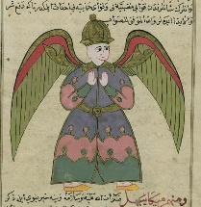  - Munkar and Nakir – judging angels – question humans.  - Raqib & Atid – Angels on each shoulder – ‘noble recorders’ of good/bad deeds. | - Muhammad  Seal of the prophets. Last and Greatest of the prophets. Only miracle that he performed was receiving Qur’an.  - Adam  Father of the human race. Formed from handfuls of different colour soil. Represents diversity of humanity. Adam disobeyed God by being tempted by devil to eat fruit. Banished to earth but Adam confessed, was forgiven, made prophet. Adam was 1st man to build the Ka’ba.  - Ibrahim (Abraham)  A hanif and one of the greatest prophets. Born to family of polytheist but rejected it and became a Muslim. Two sons – Ishma’il – ancestor of Prophet M – and Ishaq (Isaac)  - Musa (Moses)  Teachings of Ibrahim were lost so new prophet had to be sent. Musa led Israelites out of slavery in Egypt.  - Dawud (David)  One of Israel’s greatest Kings, made Jerusalem a holy place for Muslims. He received God’s word (Zabur) as hymns of praise.  - Isa (Jesus)  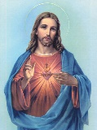  2nd most important prophet. Miracle of virgin birth accepted. Miracles of Jesus recognised and holy book of Injil recognised. Isa not Son of God and Muslims reject Trinity, Jesus didn’t die.
 | 3. Holy books
Kutub – four other holy books from Jewish and
Christian traditions. Originally true revelations from God but have been corrupted over time because not properly written down. Can’t be trusted, nothing like Qur’an in terms of authority.
- Sahifah (Scrolls of Ibrahim) lost
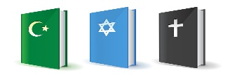
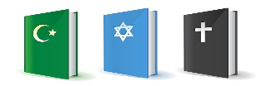
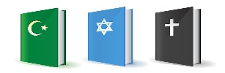
- Tawrat (Torah)
- Zabur (Psalms
- Injil (Gospels)
5. Akhirah (afterlife) | 6. Al Qadr (predestination) | Life of Prophet (570-632)
- Signs of the end of the world  Appearance of Mahdi will coincide with 2nd coming of Isa. False Messiah will try to deceive people. Signs – earthquakes, increased drunkenness, nakedness and rejection of Islam.  - Day of Judgment  ‘On the Day of Judgement the Book of Deeds will be read.’ Q 54.  All resurrected and judged on their individual deeds which are weighed. Intentions (Niyyah) also considered.  - Heaven (Janna) – state of joy, happiness and peace. Reached by bridge of As-Sirat – narrow. Paradise – reward for living good life – perfect version of earth and realisation of desires.  - Hell (Jahannam) – state of torment and suffering. Fall off bridge into hell. Place of terror, boiling water and scorching fire.  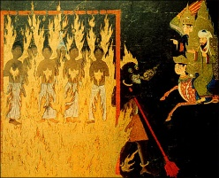  Muslims disagree with whether hell is eternal. Q says some will be sent to hell forever for certain actions. Muslims disagree if a God of mercy can eternally punish man. Some follow Shariah out of fear others out of choice. Muslims believe life is a test | God has a master plan and everything that happens is part of his design.  - God has eternal foreknowledge  ‘God knows the innermost secrets of our hearts.’ Hadith. God is omniscient (all-knowing). God knows what humans can’t know.  - Everything is part of a larger plan.  Only God knows the larger plan and the reasons for certain events and situations.  - If God is willing (Insha’Allah)  A common Muslim saying – events are outside of our individual control but in the hands of God. Statement of submission to will of God.  - Good can come from suffering.  God’s will must include suffering and pain. Muslims believes that good can come from them and that is Allah’s will. Difficult experiences are opportunities for growth.  Free Will – Humans have free will so are responsible for actions for day of Judgement. Life is a test and so humans need free will.  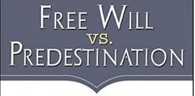 | Role model for Muslims, performed no miracles but is the perfect example of a human being.  Mecca  Muhammad born in Mecca in 570CE. Age 6 became an orphan. Worked as a shepherd (emulated Ibrahim/Dawud/Musa). Twenties – met Khadija whilst working for her. Khadijah proposed to him. Had 4 daughters and 2 sons. Prophet became troubled by corruption and polytheism of Mecca.  Laylat-ul-Qadr – Night of Power  Muhammad spent time alone in prayer and one night in 610CE –he was praying in a cave near Makkah – had an experience that would change his life. Angel Jibril appeared to him and ordered him to recite. 1st revelation of the Qur’an, revelations would continue for next 23 years until Muhammad’s death.  The message Muhammad brought to Mecca was that there was only one God who needed to be worshipped because of judgement. Message was not received well and he was ridiculed. Faced a lot of opposition.  Medina - Hijrah  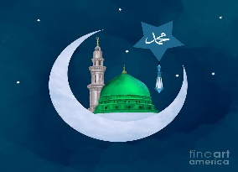  Muhammad and the early Muslims moved to Medina in a migration called the Hijrah.  Muhammad fought many battles versus Meccans including Battle of Uhud/Trench.
Return to Mecca
Muhammad returned to Mecca to conquer it as they continued to oppose his movement. When Prophet marched on Mecca with 10,000 men, they surrendered with no further bloodshed. Muhammad destroyed idols in Ka’ba. Islam established as permanent religion.

