Component 3 Islam – Practices
Key words
Ibadah – acts of worship; any permissible action performed with the intention to obey God.
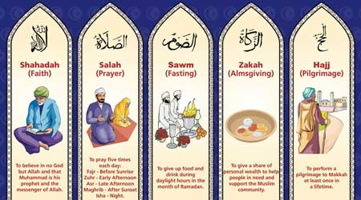
Shahadah – declaration of faith
Salah – prayer five times a day
Zakah – charity, giving money to the poor.
Sawm – fasting during Ramadan
Hajj – pilgrimage to Mecca
Niyyah (intention) – having the right intention to worship God.
Sadaqah – additional giving, separate from Zakah.
Qibla – the direction to face during prayer (towards Mecca)
Du’a prayers – personal prayers which may be said at any time of the day.
Ramadan – ninth month of Islamic year in lunar calendar. 11 days shorter than solar calendar so Ramadan moves every year.
Jihad (‘to strive’) - There are two forms of jihad.
Greater Jihad- the daily struggle and inner spiritual striving to live as a Muslim.
Lesser Jihad – the physical struggle or holy war in defence of Islam.
Id-ul-Adha – Festival of sacrifice – commemorate the sacrifice of a sheep by Ibrahim instead of his son, Ishma’il.
Id –ul Fitr – Festival of fast-breaking – end of Ramadan.
Ashura – day of sorrow & inspiration. Falls on the 10th day of month of Muharram. V Important day for Shia – commemorate death of Husayn.
Ten Obligatory Acts (Furu ad-Din) – most important practices in Shia Islam.
 | 2. Salah | Types of prayer
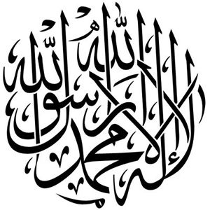 | 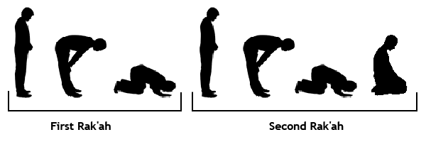  Prayer is most important way to worship God. Expected 5 times a day. Give thanks and submit to Allah. ‘Prayer prohibits immorality and wrongdoing.’ (Q 29). Preparation for prayer includes being respectful and showing reverence and concentration. Part of this is Wudu – ceremonial washing of body – hands, mouth, nose face, arms, head and feet. Sign of inner cleanliness. Sunnah indicates Muslims should pray 5X from dawn to dusk. Prayer involves prostration in ra’kah – movements of prayer. Facing Mecca. | Jumu’ah are congregational prayers which happen on a Friday at midday. Men are expected to attend the mosque.  Du’a is personal prayer which takes place after prayers of duty.  If Muslims miss a prayer they should make it up – ‘If one of you sleeps or misses a prayer…let him offer the prayer when he remembers.’ Hadith.  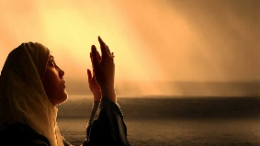  When Muhammad went on night journey he received the instruction from Allah through negotiation of Musa to pray 5X a day.
1. The Shahadah
The declaration of faith which says ‘There is no god but God and Muhammad is his prophet.’ The other four pillars are outward expressions of this deeply held belief. ‘God witnesses there is no deity except Him.’ Q 3
Shahadah is repeated in Salah daily and also in call to prayer. Furthermore, these are first words whispered into new born baby’s ear. Testament to monotheism (belief in one God). 1st pillar said to become a Muslim or revert; all born Muslims and so return to faith.
3. Zakah | 4. Sawm | 5. Hajj
All Muslims are expected to perform Zakah as a regular duty by giving 2.5 %. Qur’an commands to give to those in need. It is an obligation and a form of worship. Zakah is a sign of cleansing and purity. Wealth can cause greed which is evil, Zakah is a way of purifying wealth. Our wealth is not ours but given by God and must be shared with other humans for benefit of all. Humans have a role as khalifahs (stewards) – God’s representatives on earth. That means that humans are looking after this world and possessions to pass on to the next generation. Therefore Muslims should view possessions as their own. The Prophet Muhammad practiced zakah as a practice when he became ruler in Medina. Those that can receive Zakah include the poor, needy and travellers. There are also Muslim charities such as Islamic Relief and Muslim Aid which focus on healthcare and education projects in developing countries. Sadaqah is giving from the heart out of generosity and compassion | Fasting should take place during Ramadan and is considered the holiest month of the year because it is the month when Prophet Muhammad first received revelation of the Qur’an. Fasting is a way of practicing self-control by refraining from eating, drinking, smoking and sex from dawn til dusk for 30 days. It is a time of purity and worship. Starts with new moon and ends with Id-ul-Fitr (celebration). Fasting is broken each day after the sun has set with the iftar meal. These meals are often very social with friends, family and neighbours. Muslims recite the whole Qur’an over Ramadan during special night prayers. On 27th day, Muslims celebrate Laylat-ul-Qadr – Night of Power – revelation of Qur’an. Why do Muslims Fast? Commanded in Quran. Follows example of Prophet. Brings Muslims closer to each other. Worship Allah. Reminds Muslims of hungry and poor. Promotes self-control.  Who should fast? All except those young, ill, travelling. | Only pillar that is not compulsory. Compulsory for those who are able to make it physically and financially. Hajj is often the ambition of a lifetime. Haji (male) and Hajjah (female) are special titles for those who complete Hajj – great honour.  Importance – Ibrahim threw stones at devil to drive him away when he was being tempted not to follow God’s order to sacrifice Isma’il. Ibrahim’s wife, Hajar, searched frantically for water in desert. Miraculously shown Zamzam well. Ibrahim built Ka’ba. Mecca was where Prophet was born, received revelations, returned to reclaim city. Hajj takes believers to sacred sites around Mecca, Saudi Arabia. Muslim men will wear two white sheets. Women must wear plain long garment. State of Ihram – purity during Hajj.  Key events – Tawaf – circling Kaba. Walk 7 times between Mawah and Safa like Hajar. Drink from Zamzam well. Wukuf –standing on plain of Arafat remembering God’s forgiveness. Mina – throwing stones pillars (representing devil.)
Greater Jihad | Lesser Jihad | 10 Obligatory Acts (Shi’a)
Duty to remove evil from society, Muslims must fight for justice in the world when you have removed evil from your own life. Greater Jihad is struggle within oneself. It is non-violent and spiritual. Jihad (struggle) is required to perform five pillars, follow Sunnah, seek justice and avoid temptation. The battle against laziness. Jihad is a commitment to be a better person to get up for prayers and to follow the Shari’a. Muslims should ‘encourage what is right and forbid what is wrong’ (Q.3) as part of greater jihad to make the world a better place. Muslims should be respectful of other faiths ‘To you be your religion, and to me mine.’ (Q 109. Part of greater jihad is tolerance. On his return from a battle, the Prophet said:  "We are finished with the lesser jihad; now we are starting the greater jihad." | Lesser Jihad is military struggle or holy war. In certain circumstances force should be used. Lesser jihad is struggle to remove evil from society.  Origins  When Prophet Muhammad and early Muslims were being attacked and oppressed by the Meccans, no choice but to engage.  “Fight in the way of God those who fight against you but do not transgress.” (Quran 2)  Conditions  Not aggressive but self-defence.  It should be proportionate.  Must have a legitimate authority or state behind it.  Civilans must not be harmed.  Islamic Extremism  Some terrorists claim to be using lesser jihad in their terror attacks such as 9/11. However, moderate Muslims reject this idea since it doesn’t meet the conditions for jihad. These attacks injure civilians and are not from a legitimate authority. Islamic State is another example of a group using violence to create a state with Shariah law using barbaric methods. Muslims reject that this is ‘Islamic’. | 1 Salah Praying 5 times a day at 3 different points.  2 Sawm Fasting during Ramadan. Fast is broken once the sun has fully set.  3 Hajj Pilgrimage to Mecca & Karbala (Husayn) & Najaf (Ali).  4 Zakah Alms given 2.5%  5 Khums Tax set at 20% for causes decided by Shia leaders  6 Jihad Striving in the way of Allah  7 Amrbil ma’roof Encouraging good actions  8 Nahi anil munkar Discouraging evil actions  9 Tawalla Association with good people eg those who follow the ahl al -bayt  10 Tabarra Dissociation with evil people  1st 4 obligatory acts are found in Sunni 5 pillars. Excludes Shahadah.
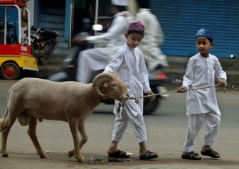
Other Festivals | Ids | Ashura
Mawlid an-Nabi – Birth of the prophet. It is a public holiday in many Muslim countries. Muslim Britons celebrate this day with joyful processions.  Laylat-ul-Qadr – Night of Power. Celebrated during Ramadan because it was first revelation of the Qur’an.  Laylat-ul-Miraj – Night journey. Celebrate time when Prophet Muhammad travelled to Jerusalem and then to heaven to the presence of Allah. Muslims tell the story to children and recite special prayers. Events at mosque.  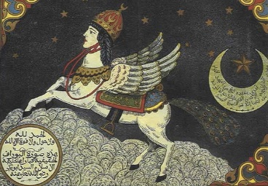  Laylat ul-Bara’at – Night of the full moon before Ramadan. The night Muhammad would begin his preparations for Ramadan. Some Muslims stay up all night reciting the Qur’an.  Muharram  1st month of Muslim calendar, same month as Hijrah. More significant for Shi’a then Sunnis. Refrain from joyous events as Husayn was martyred. | Id-ul-Adha – festival of sacrifice.  Marks end of annual Hajj pilgrimage.  Chance for whole Ummah to celebrate, special for all Muslims not just those on Hajj.  Origins  Ibrahim’s commitment to God in being willing to sacrifice his son, Ishmael.  God was testing Ibrahim and provided a sheep for him to sacrifice instead.  Key events  Gifts bought, new clothes, food prepared, arrangements made for sacrifice.  Visit mosque to pray, visit friends/relatives. Not official holiday in UK. Sacrifice an animal. People ask a butcher to slaughter a sheep for them and share the meat with the community. Giving this meat to the poor is a sacred duty.  This Id should be a day of true sacrifice not in terms of animals or meat but in terms of a sacrifice within the heart of each Muslim.  Id-ul-Fitr – Festival of fast-breaking  At end of Ramadan. Public holiday in Muslim majority countries, not in UK.  Key events  Decorate homes with colourful light, banners, flags. Dress in best new clothes. Gather in mosques. Say ‘Id Mubarak’. Visit family and friends. Give gifts /money to children. Eat a delicious meal. Give to poor. Cultural celebrations India- women apply Henna. Turkish children given sweets.  Zakah ul-Fitr – donation to the poor so that everyone can eat a generous meal at end of Ramadan. In addition to 2 | Sunni celebration  Many fast on this day which was established by Prophet Muhammad as a day of fasting based on Jewish day of atonement. Time to thank God for saving Israelites from Egypt.  Shia mourning – Martyrdom of Husayn  Husayn was murdered and beheaded at the Battle of Karbala in 680CE. Husayn is 3rd Imam and rightful successor of Prophet. Remember his betrayal and death with deep sense of injustice.  Practices  Processions, Plays, public displays of grief on the streets. Blood often spilled and people cry and wail.  Day of great sorrow and self-mutilation with public grief. Often Shia will make pilgrimage to Karbala. Wear black, slap chests, chant, processions, re-enactments of martyrdom, men beat themselves with chains and cut heads with swords.  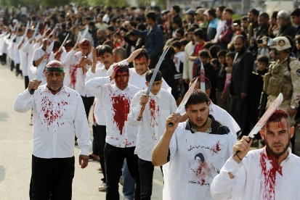  Ashura in Britain  Not a public holiday but Shia Muslims may be given permission to have day off school. Public marches in London and Manchester. Not often bloodletting but instead may give blood.

