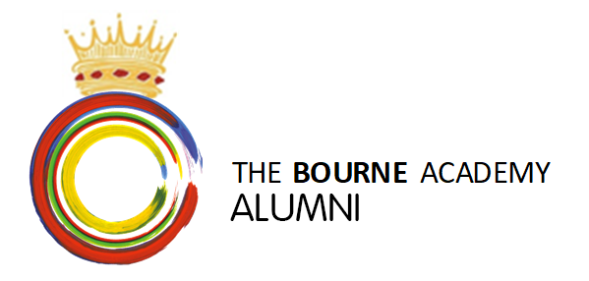
Join our Alumni
Welcome to our Celebration of Success Presentation Evening. Congratulations on all your achievements during your time at The Bourne Academy – we are delighted you are here with us to celebrate this evening.
We would like to take this opportunity to invite you to complete the below form which will enable us to stay in touch with you. Our Alumni contacts receive occasional updates from us along with opportunities to attend events, invigilating exams (paid) and mentoring opportunities. You need to ‘’opt in’’ for us to retaining your personal contact information. (GDPR requirements) Please therefore take a couple of moments to complete and hand in this form.
Your data will be kept in strictest confidence.
First Name |  |  | Surname |  |  |  | Date of birth
Address:
Personal Email Address
Not Academy email address
Contact Telephone Number
Year of Leaving The Academy
Destination: What are you intending to do after leaving The Bourne Academy?  Please circle as appropriate |  |  | Work Apprenticeship Further Study (TBA Sixth Form)  Voluntary work taking time out Further Study (externally)
Course or job title
Level of study or apprenticeship If appropriate
College, Sixth Form, University, Employer name
Start Date |  |  |  |  |  |  | Expected duration
When you leave The Bourne Academy you become one of our Alumni (a former student); we would like to stay in touch with you and share news and invite you to events. I want to join The Bourne Academy Alumni and receive invitations to all Academy events and productions, reunions hosted at the Academy. |  |  |  |  |  |  | Please tick here:
Signed: |  |  |  |  |  | Dated:
Please tick any of the following ways in which you might want to get involved in future:
Mentoring students |  |  |  |  | Fundraising
Offering work experience |  |  |  |  | Other volunteering
Offering careers talks |  |  |  |  | Becoming a Governor
Invigilating during exams |  |  |  |  | Organising Alumni events
Please write down any ideas you have for future Alumni events or communications.

Please hand in to a member of staff on the way out this evening. We very much look forward to keeping in touch with you in the future.

